**INHA UNIVERSITY TASHKENT**

**DEPARTMENT OF CSE & ICE**

**SPRING SEMESTER 2019**

**SOC 2040 - SYSTEMS PROGRAMMING**

**LAB ASSIGNMENT 5**

**Submitted by**

**Student Name Student ID**

**Group : Sophomore**



**INSTRUCTIONS :**

**- ALL LAB ASSIGNMENTS ARE TO BE COMPLETED IN GROUPS OF MAXIMUM 6 STUDENTS.**

**- ALL PROGRAMS REQUIRED FOR QUESTIONS Q1) TO Q8) OF THIS LAB ASSIGNMENT ARE GIVEN IN A FOLDER sp5programs AT THE ECLASS ARCHIVE.**

**- LAB ASSIGNMENT REPORT SHOULD BE PREPARED USING THE LAB ASSIGNMENT 5 REPORT TEMPLATE PROVIDED.**

**- IN THE REPORT, FOR EACH QUESTION YOU NEED TO PROVIDE ALGORITHM, PROGRAM SCREENSHOTS, COMMAND EXECUTION AND RESULTS SCREEN SHOTS.**

**- SOURCE CODE FOR ALL THE PROGRAMS AND RESULTS OUTPUT FILES FOR ALL QUESTIONS SHOULD BE UPLOADED ALONG WITH THE LAB REPORT AT THE E-CLASS PORTAL.**

**- ONE HARD COPY OF THE LAB ASSIGNMENT REPORT OF EACH GROUP SHOULD BE HANDED IN AT THE OFFICE BY THE GROUP LEADER.**

**- EVERY MEMBER OF THE TEAM MUST UPLOAD THE SOFTCOPY OF THE REPORT AT THE E- CLASS PORTAL.**

**- LAST DATE FOR SUBMISSION OF THE LAB ASSIGNMENT REPORT IS 6th MAY 2019**

**- LATE SUBMISSIONS ARE NOT ENTERTAINED, ADHERE TO THE DEADLINE STRICTLY**

**- READ THE QUESTIONS CORRECTLY & CAREFULLY**

**Question 3**

**waitonchild1.c**

parent prints hello parent waits for child to reap child prints hello and terminates parent prints child terminated and terminates

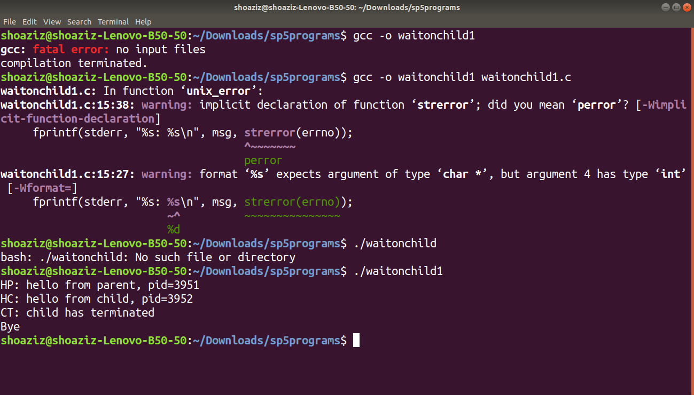 **simplewait_childao.c**

in this program parent reaps child without order but waits until all of them are terminated then parent terminates

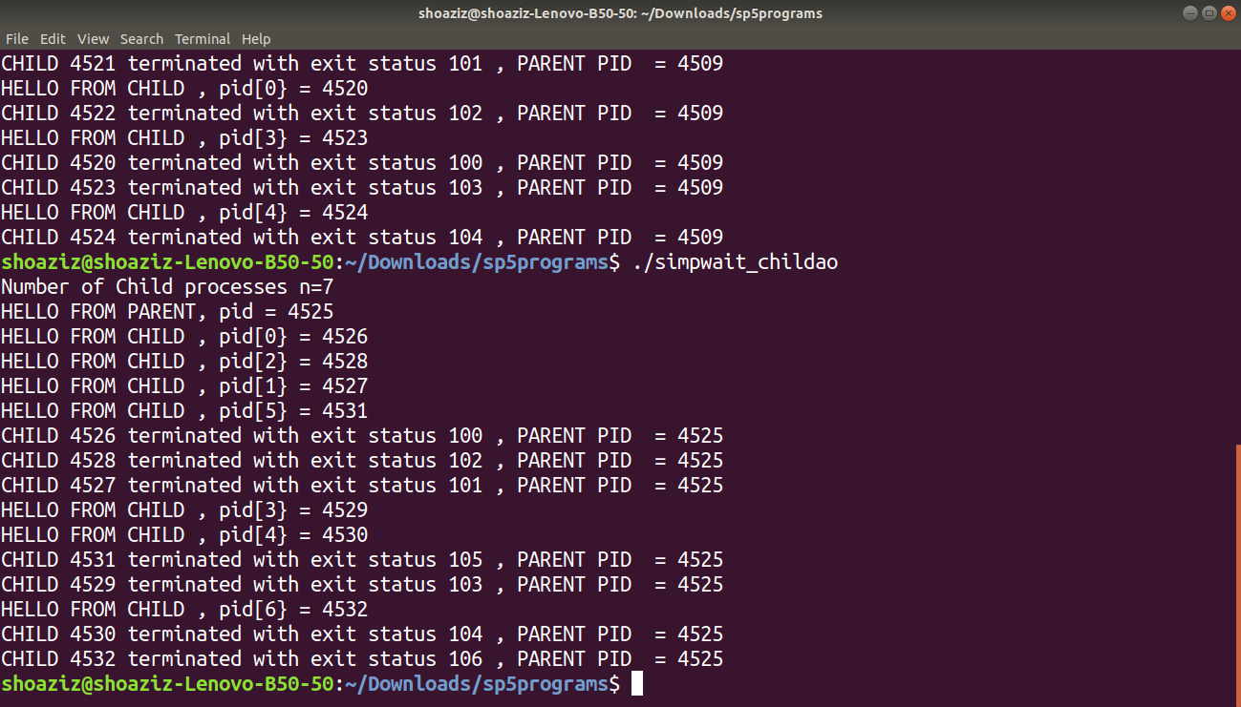 **waitpid_childao.c**

in this program parent reaps child without order in which they were created order, waits until all of them are terminated then parent terminates

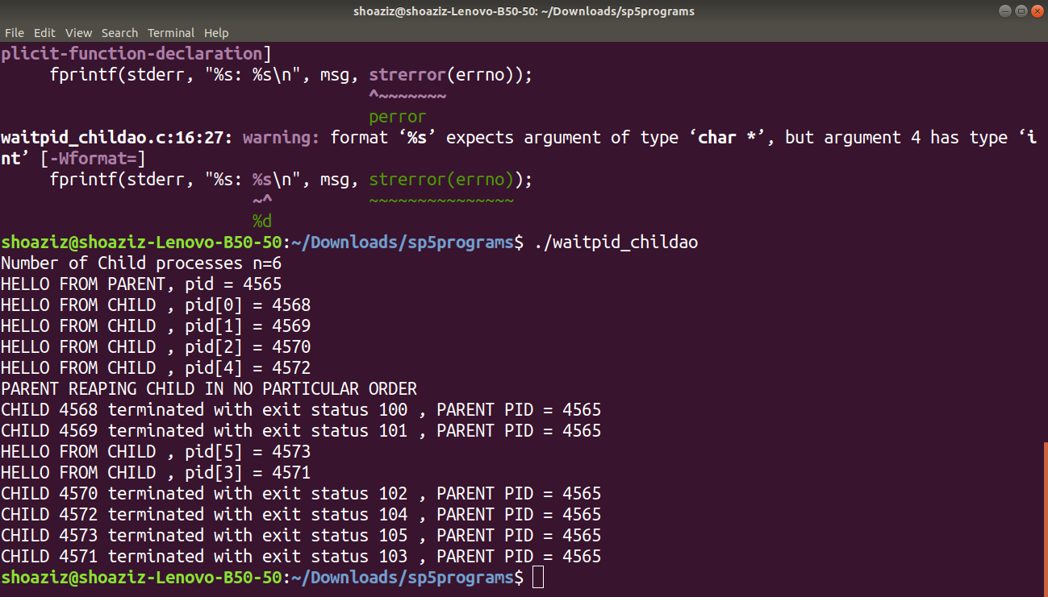

**waitpid_childco.c**

in this program parent reaps child without order in which they were created order, waits until all of them are terminated then parent terminates

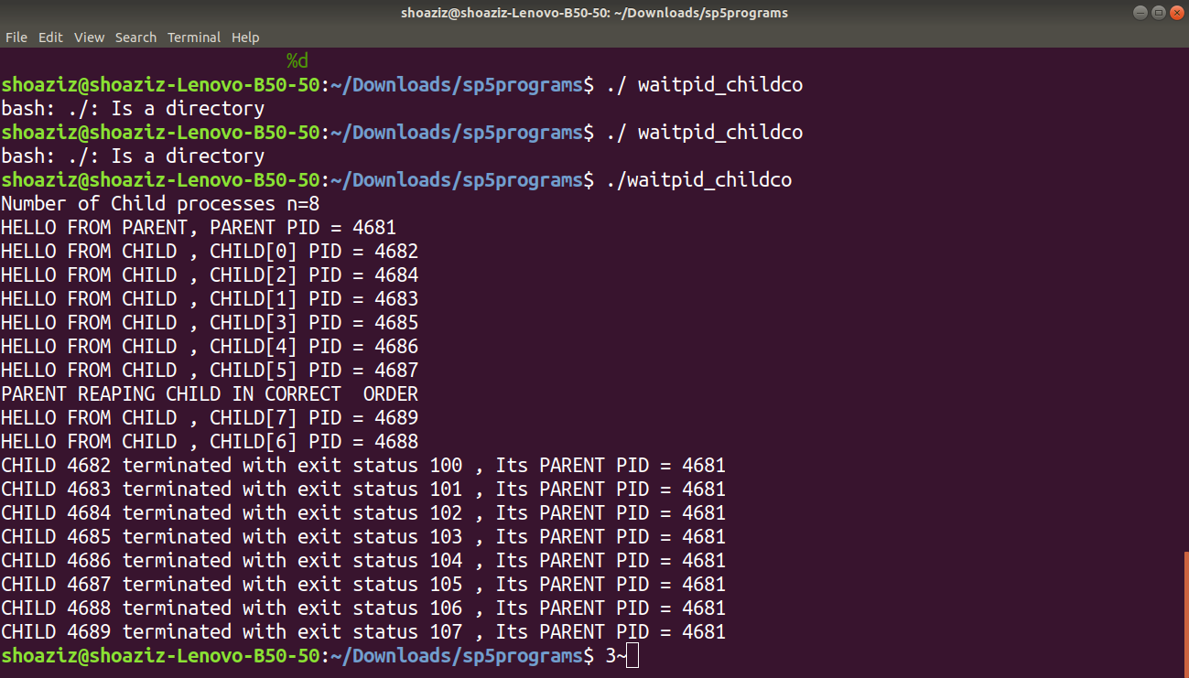

**waitpid_childrco.c**

in this program parent reaps child without order in which they were created order, waits until all of them are terminated then parent terminates

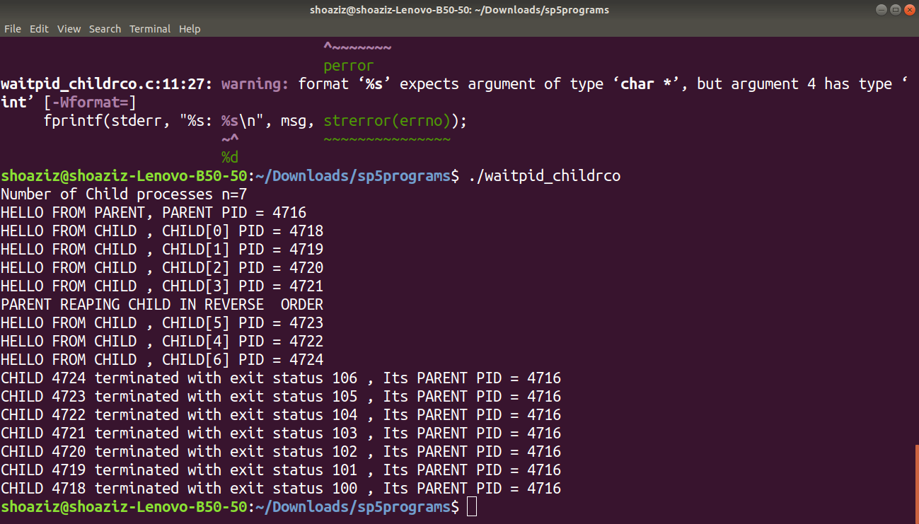

**waitpid_childsleepco.c**

in this program parent will reap child as soon as the weak up the first child to wake up will be reaped first

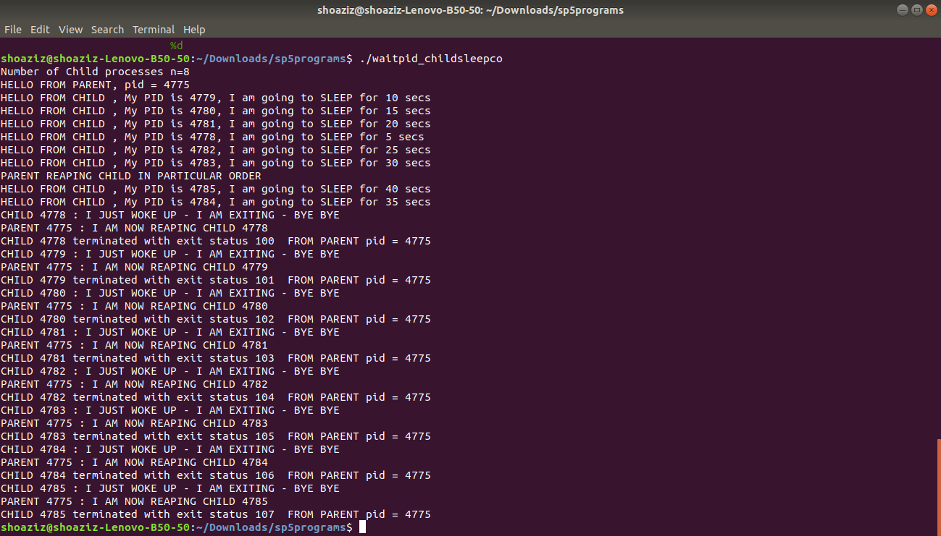

**waitclktchild.c**

this program parent doesn’t reap child in any order it just waits and when clock cycle comes it reaps

and shows when it was reaped

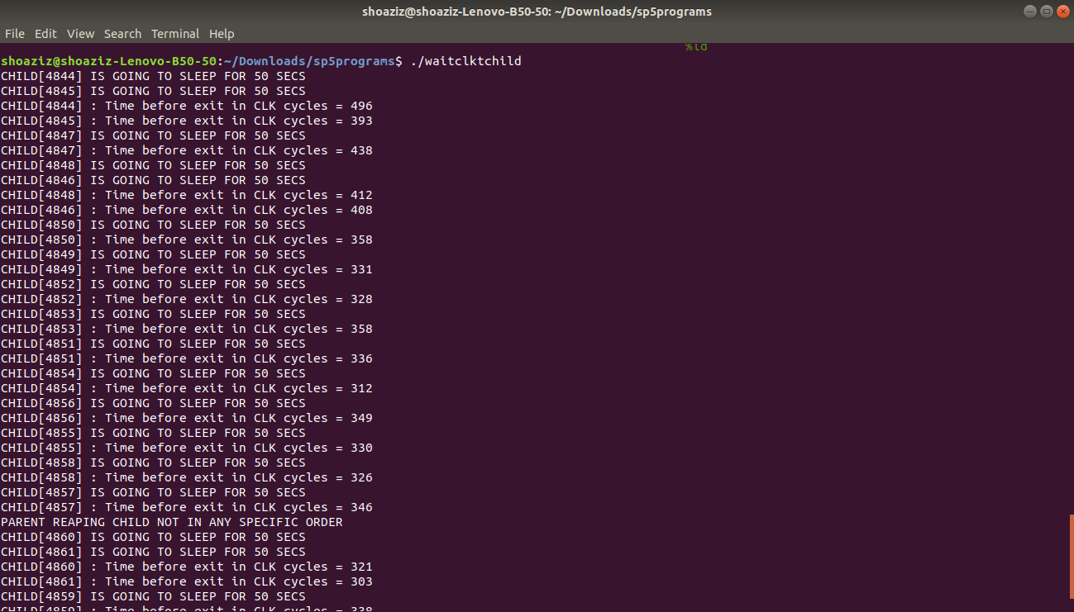

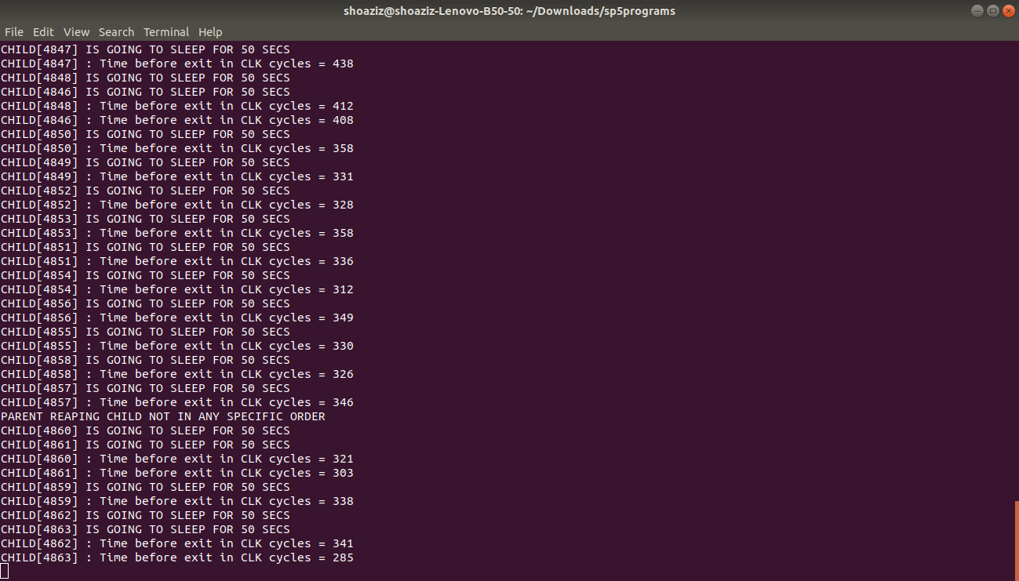

**Problem 7)**

**threadvshare.c**

Global variable ptr is shared by both programs

cnt variable is also shared because there is only one copy of that variable

var myid is not shared because its initialized and created inside thread other variable inside main is also

not shared

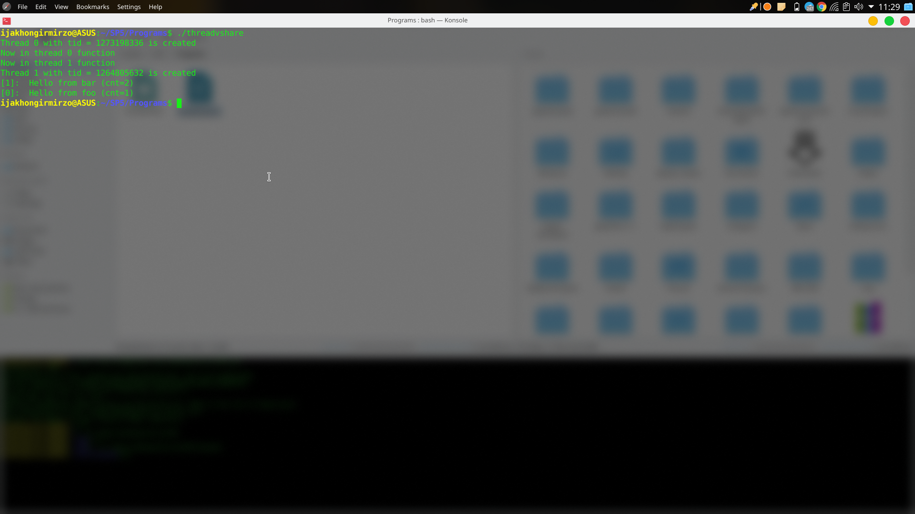

**Problem 8)**

**a) Input 1 - $badcntn 10000 200**

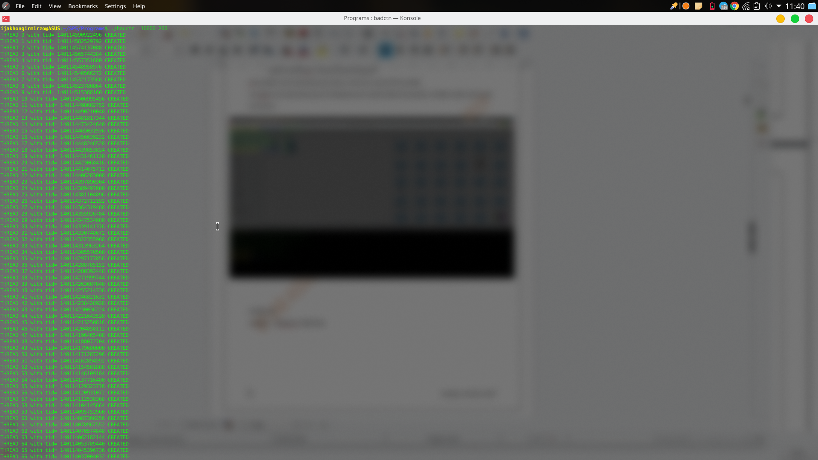

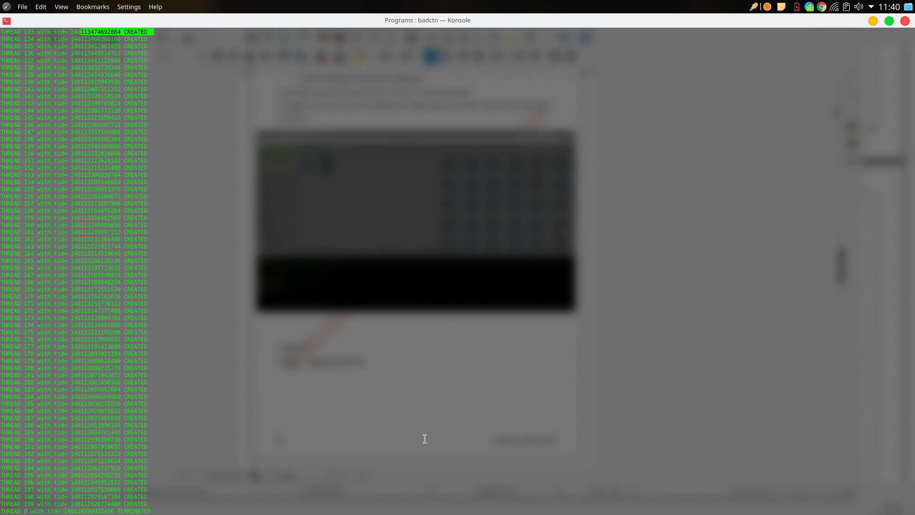

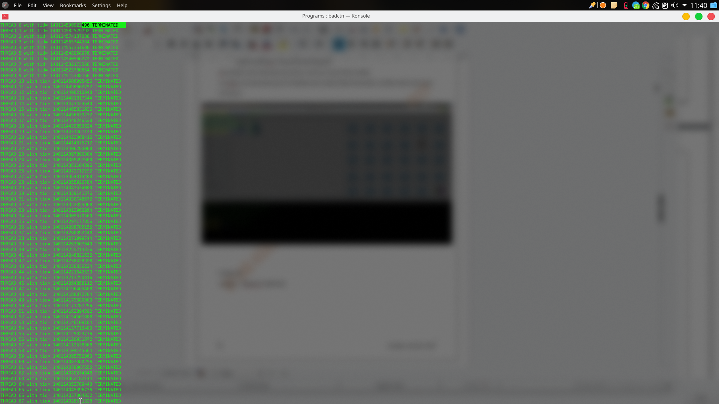

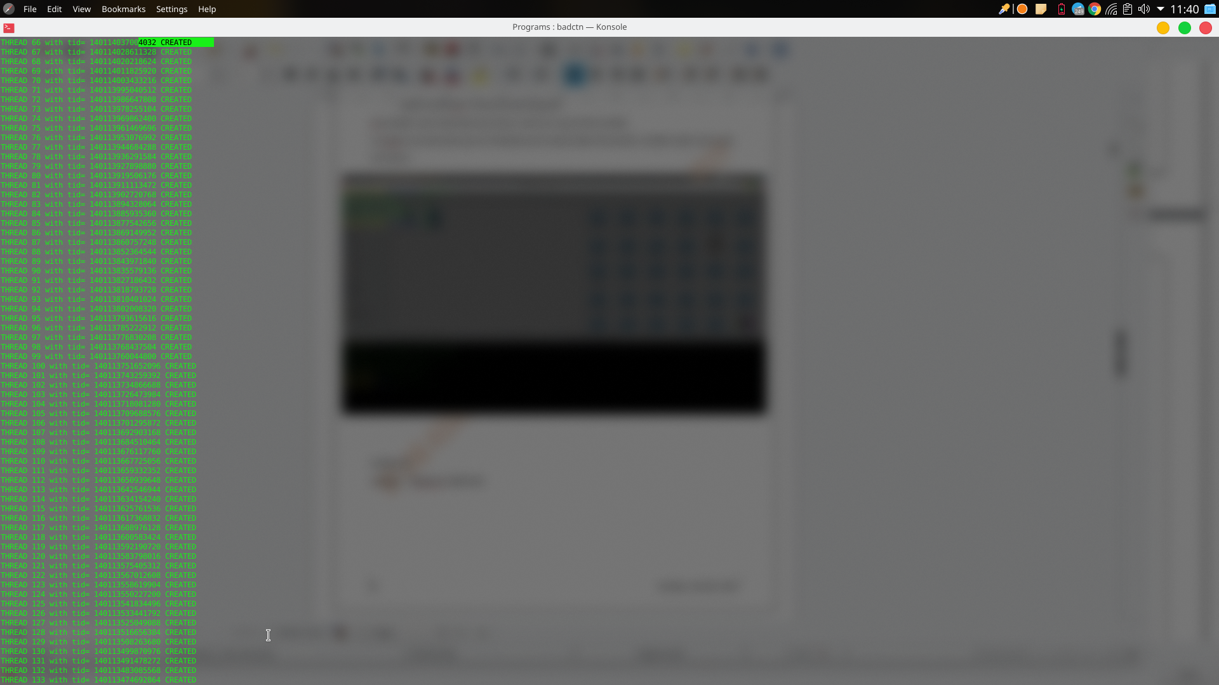

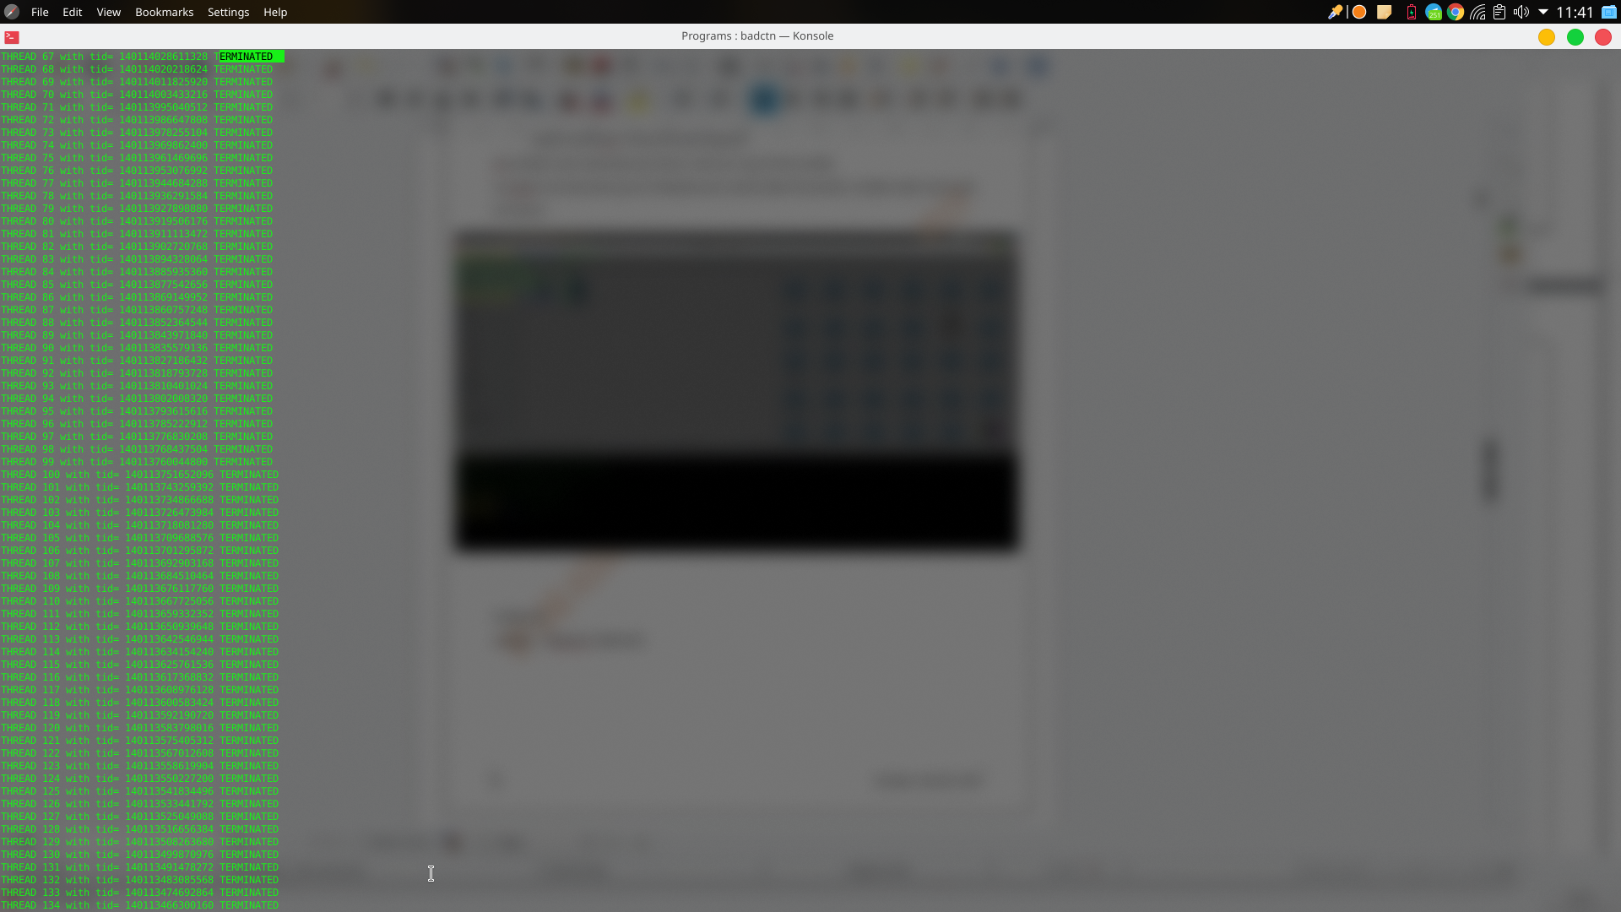

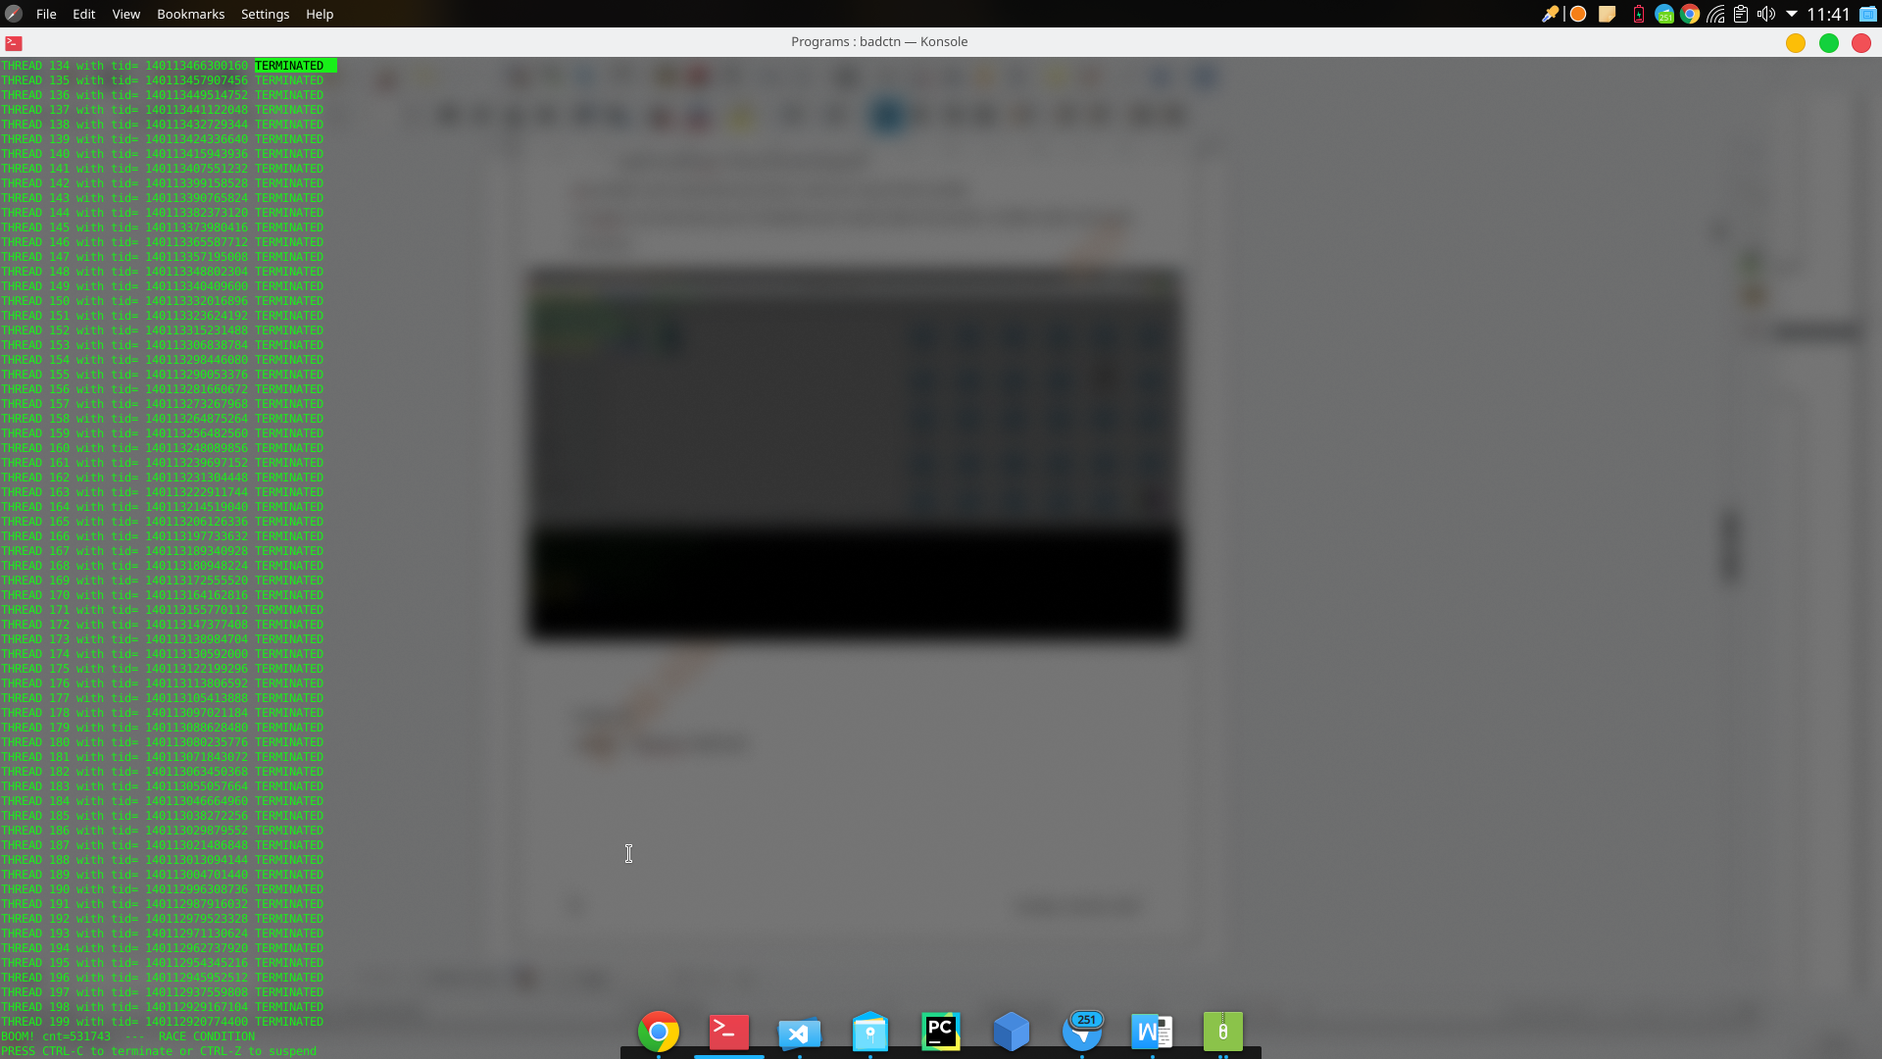

**Input 2 - $badcntn 10000 200**

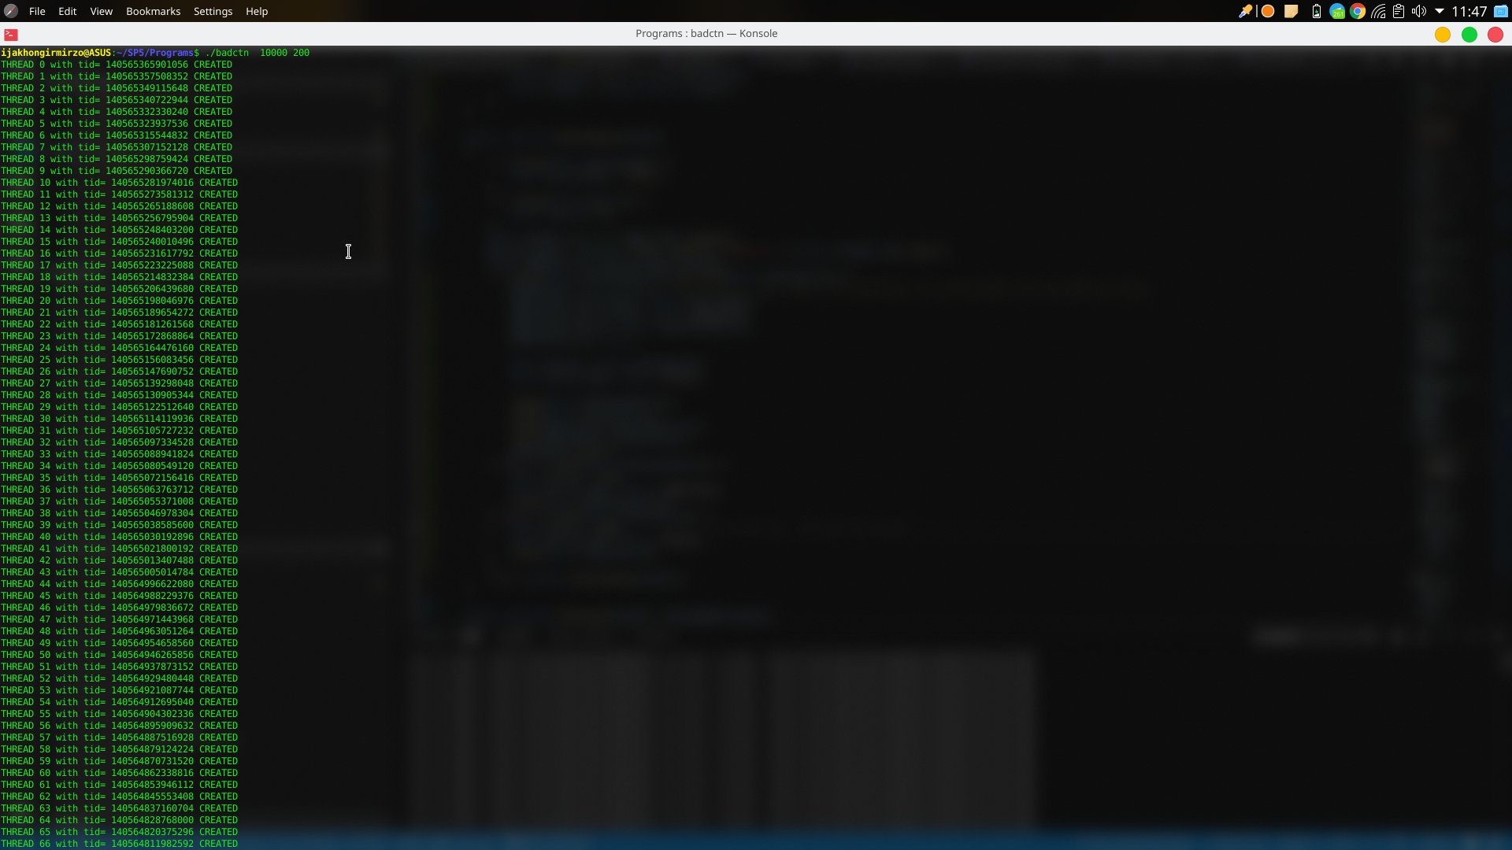

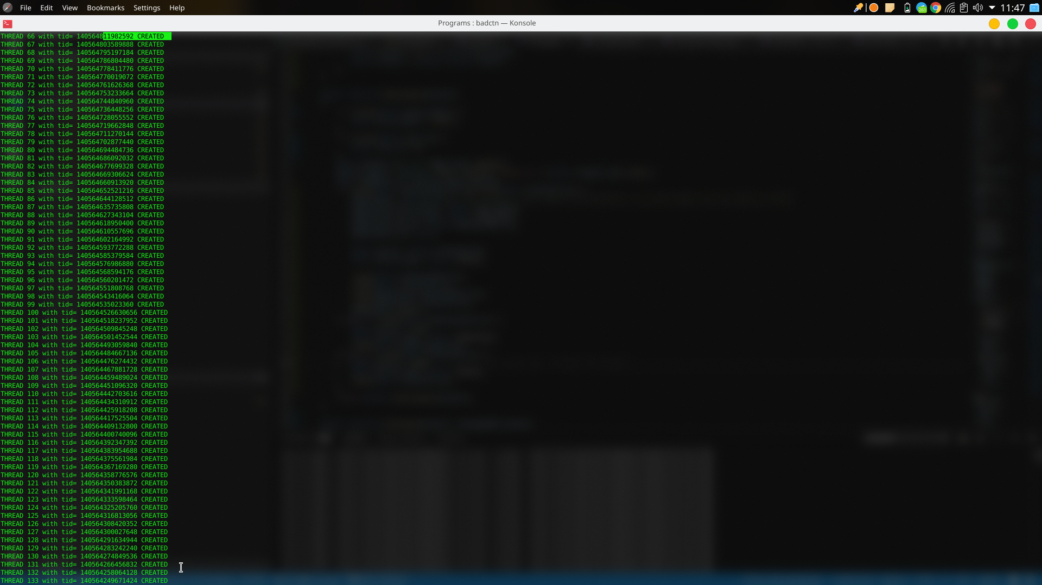

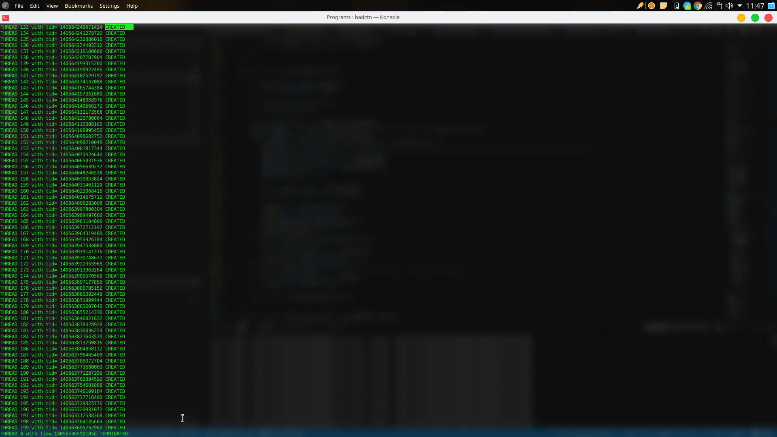

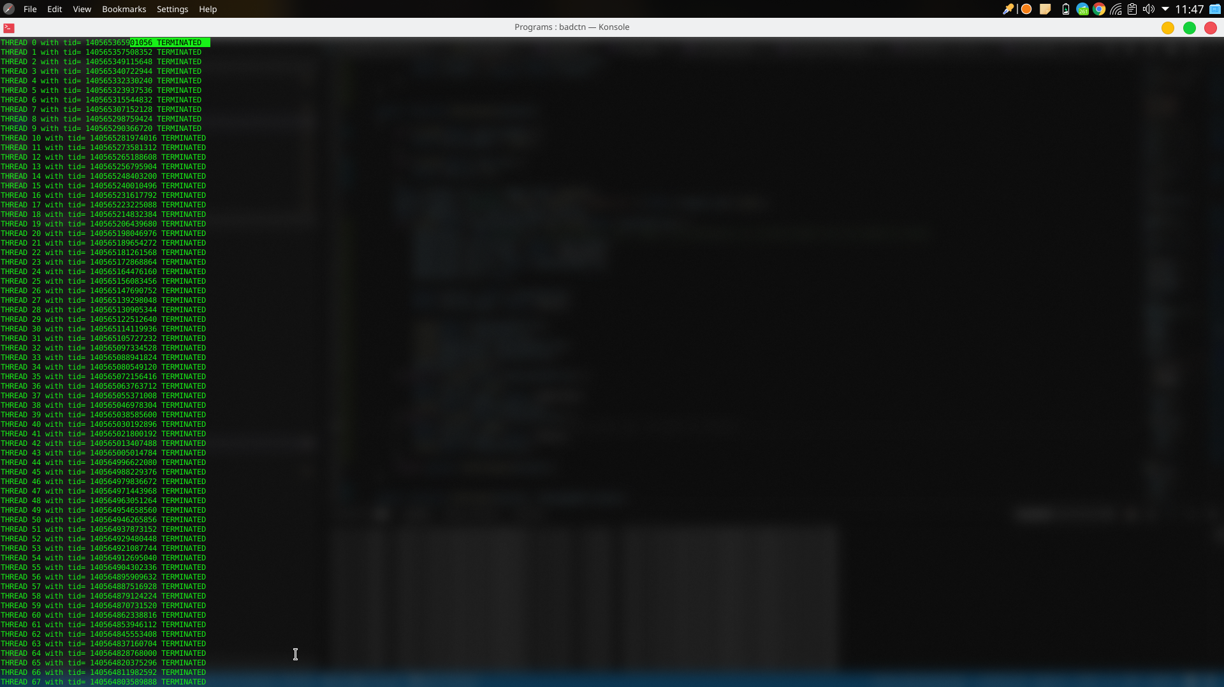

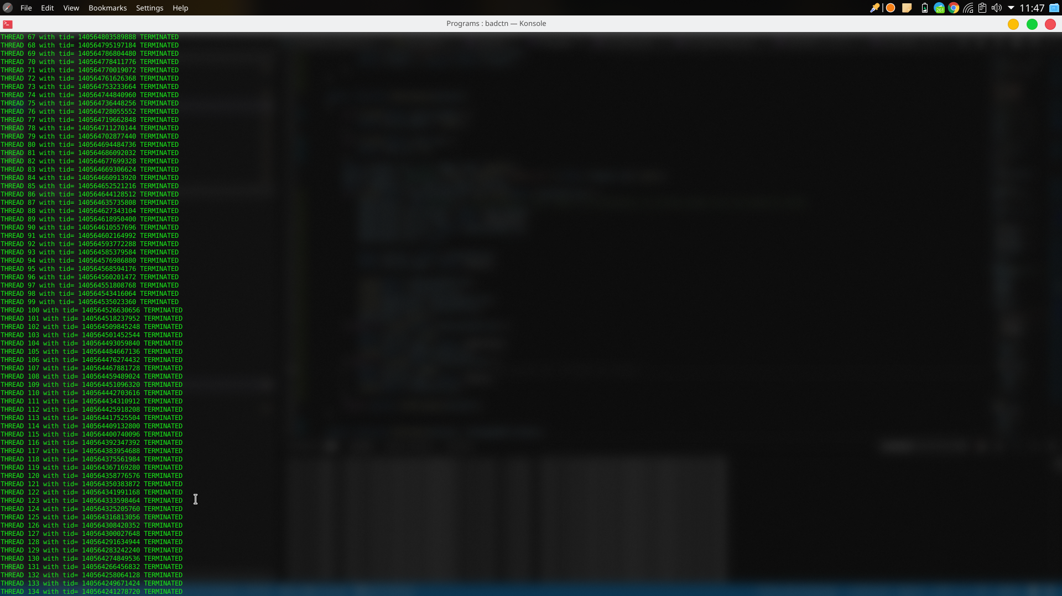

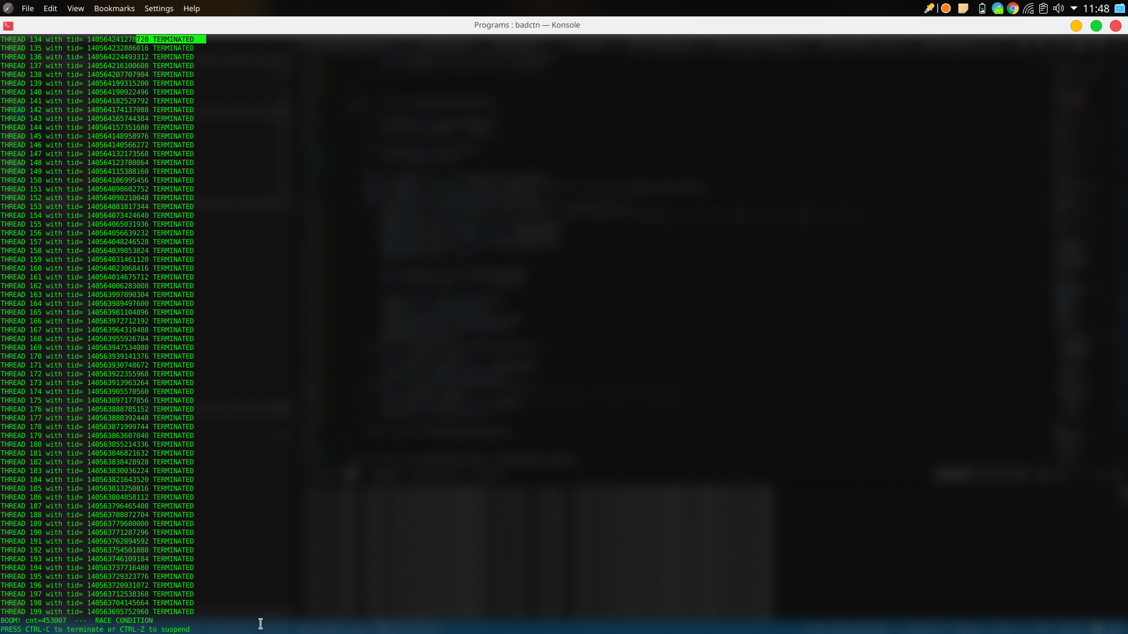

**B)**

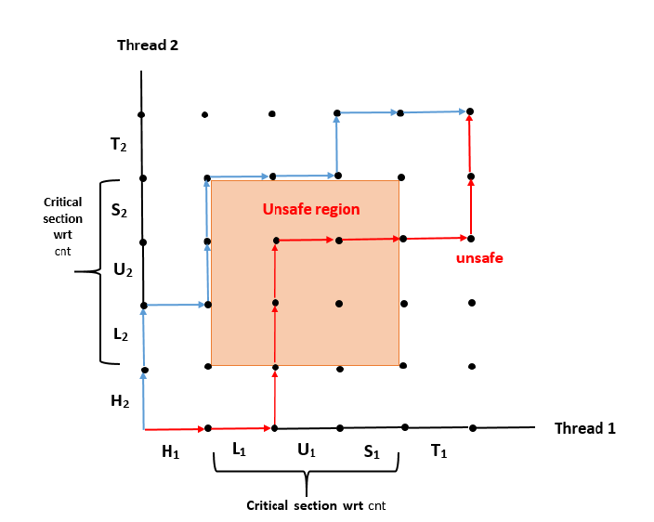

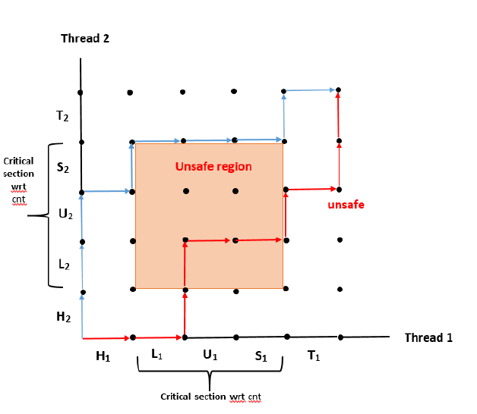

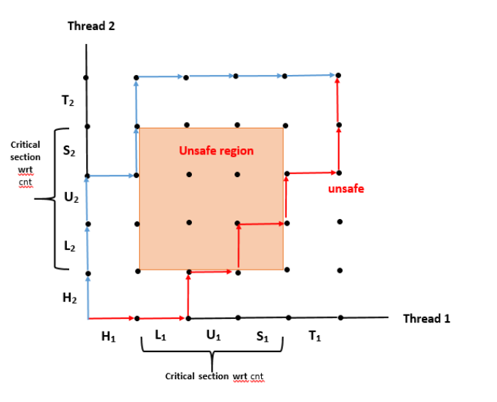

**G)**

/* Compile the program using the command on linux : $ gcc -pthread -lrt -o goodcntn goodcntn.c

*/

/* To execute the program enter: $ ./goodcntn 10000 200 */

#include#include#include#include#include#include#include#include#include<pthread.h>

<stdio.h>

<stdlib.h>

<sys/types.h>

<signal.h>

<sys/wait.h>

<unistd.h>

<errno.h>

<semaphore.h>

void P(sem_t *s)

{

sem_wait(s);

}

void V(sem_t *s)

{

sem_post(s);

}

int pthread_create(pthread_t *thread, const pthread_attr_t *attr, void *(*start_routine) (void *),

void *arg);

void *thread(void *vargp);

/* Global shared variable */

volatile long cnt= 0; /* Counter */

/* Semaphore that protects cnt*/

//then initialize it to unity in the main routine:

sem_t mutex;

int main(int argc, char **argv)

{

sem_init( &mutex, 0, 1);

long niters;

int i, nthreads;

pthread_t tid[1000];

niters = atoi(argv[1]);

nthreads = atoi(argv[2]);

for (i=0; i < nthreads; i++)

{

pthread_create(&tid[i], NULL, thread, &niters);

printf("THREAD %d with tid= %ld CREATED \n", i, tid[i]);

}

for (i=0; i < nthreads; i++)

{

pthread_join(tid[i], NULL);

printf("THREAD %d with tid= %ld TERMINATED \n", i, tid[i]);

}

/* Check result */

if (cnt != (nthreads * niters))

printf("BOOM! cnt=%ld --- RACE CONDITION\n", cnt);

else

printf("OK cnt=%ld\n", cnt);

printf("PRESS CTRL-C to terminate or CTRL-Z to suspend \n");

pause();

exit(0);

}

/* Thread routine */

void *thread(void *vargp)

{

long i, niters = *((long *)vargp);

for (i = 0; i < niters; i++)

{P(&mutex);

cnt++;

V(&mutex);

}

return NULL;

}

**Input 1 - $goodcntn10000 200**

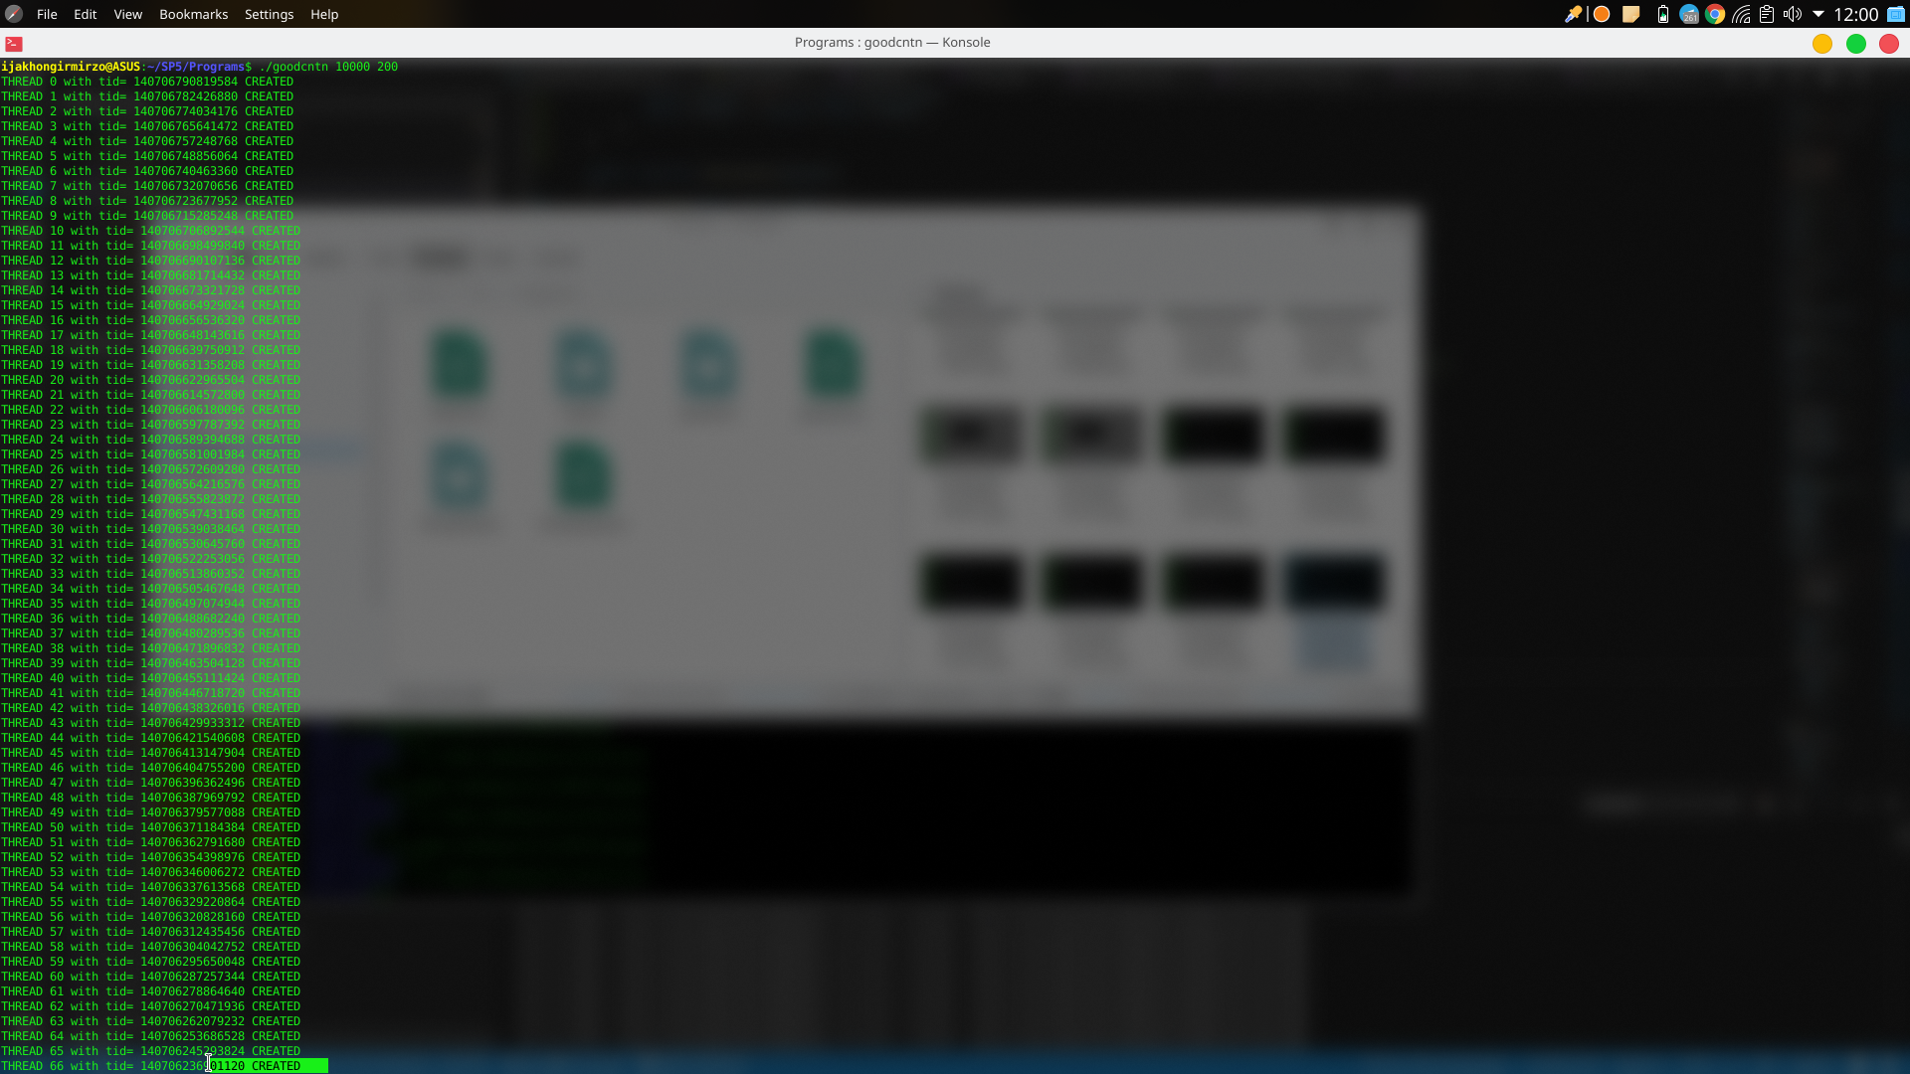

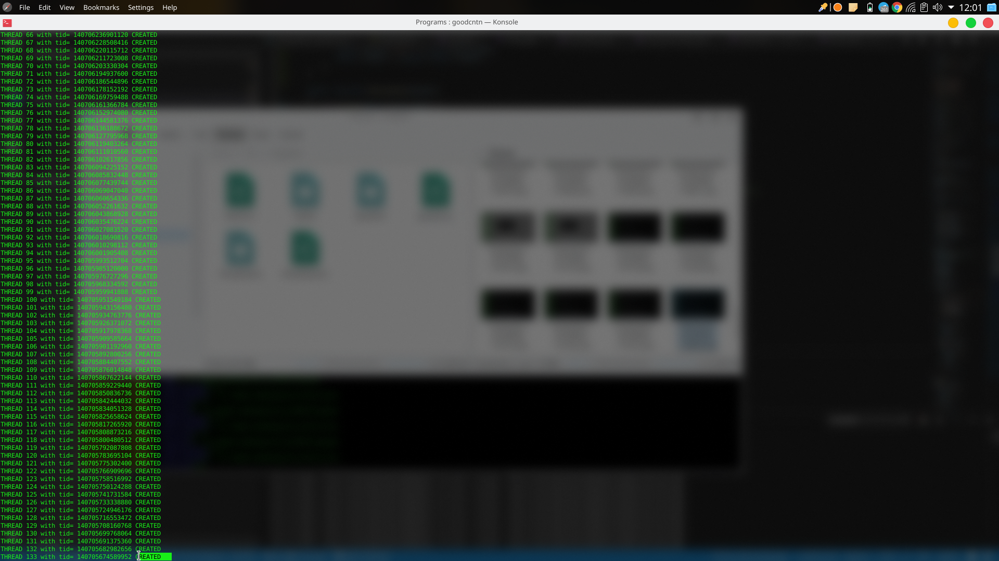

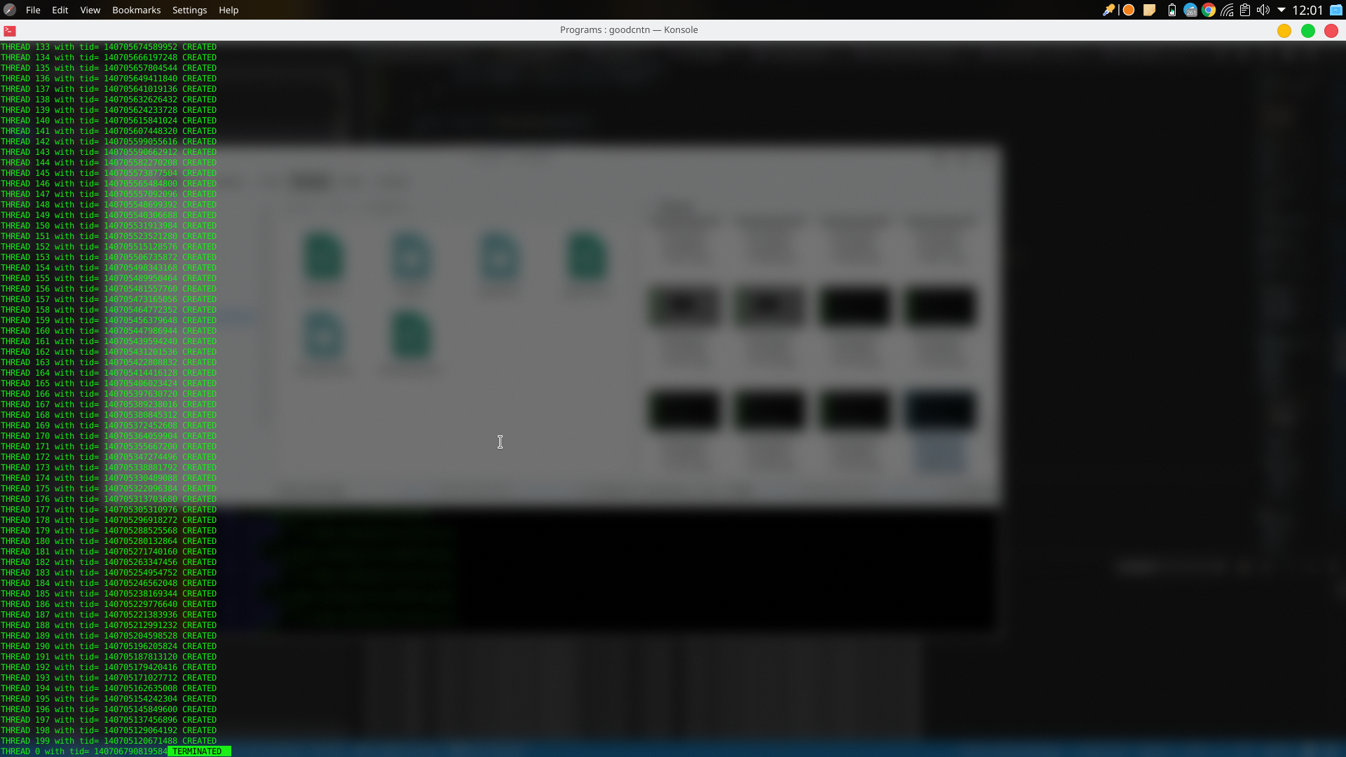

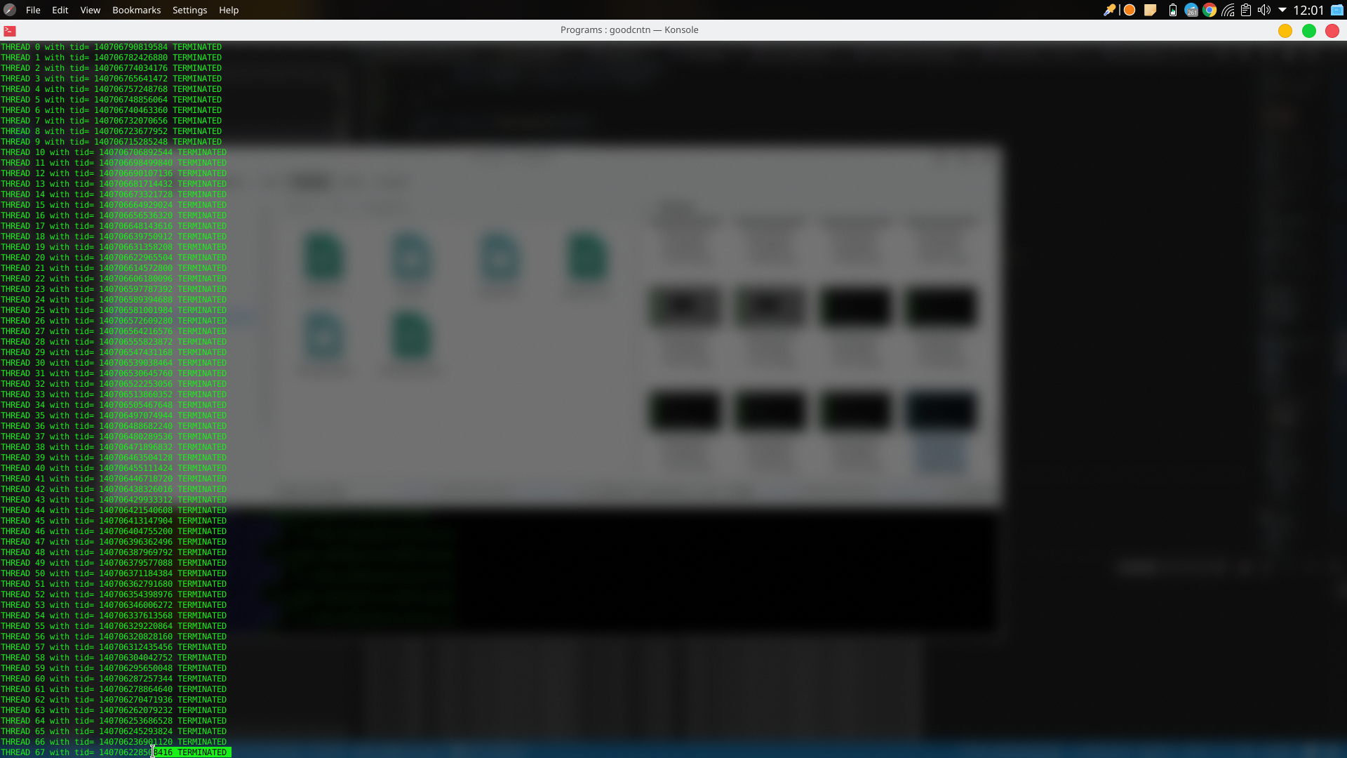

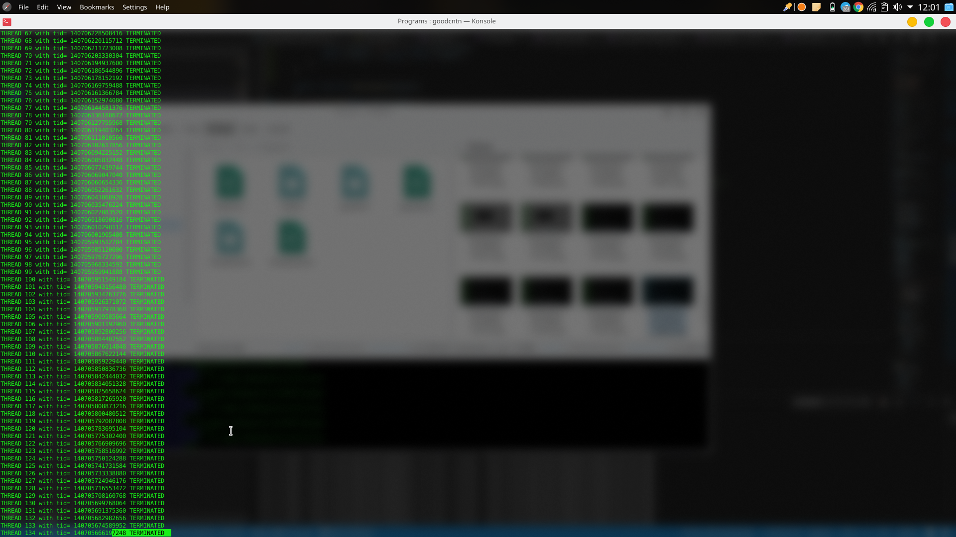

**Input 2 - $goodcntn 10000 200**

